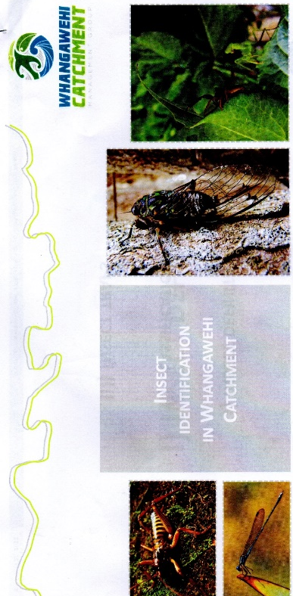

Whangawehi Catchment Insect Survey
2018
Insect survey 2018 - Janice Edwards
My thanks to Nic and Pat in giving me transport
and help in this project.

The survey was conducted approximately 14 months since the 2017 survey. Weather conditions, access and time constraints made an earlier survey impossible. The weather had been very hot with drying winds. Even night time temperatures were quite warm during this 2018 set period.
For ease of access we have set the traps 1 & 2 (near the previous sites) but on the Whare side of the Whangawehi within the newly planted area. The whole planting was quite dry but vegetation was lush.
Trap site 1 – Just off a path through the plantings. Sheltered, grassed area. Set early Nov
Trap site 2 – Approx 60m away in a sheltered, heavily grassed area in the growing trees. Set early Nov
Traps were in place for 7 days.
Trap site 3 - Last surveyed 2016 This year the wetland has shown a lot of new growth but the area is quite dry. Set mid-November.
Trap site 4 - Placed on the edge of bush that was retired from farming about 10 years ago. On a steep slope within a gully. Set mid-Nov.
Traps 3 & 4 in place for 7days.
During that time, one of the bottles on Trap 4 slowly leaked it’s alcohol but the insects in the bottle were still preserved and moist.

In 2016 traps were set in 4 places and were each set twice during August. To give some comparison I have included both insect takes in the 2016 figures.
I believe we need to be more accurate in setting nets at the same time each year (within a week or so). This year our insect collection for traps 1 & 2 all but missed the moths and butterflies that appear during earlier months. The weevils in the Coleoptera Order seen last year were mostly absent from this year’s take. While some numbers were down on last year, there was still quite a diversity of insects – though the hundreds of the caught bugs were extremely tiny and could fit on a dinner plate for counting – and almost every order of insects was represented.
I am also getting better and quicker at counting the extremely tiny bugs and by keeping them in a fluid to count, I can easily see that a black dot with legs or wings is different from a detached wing of another insect.

 | Trap 1 |  |  | Trap 2 |  |  | Trap 3 |  |  | Trap 4
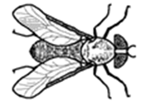  Diptera  flies, mosquitoes | 2016 | 2017 | 2018 | 2016 | 2017 | 2018 | 2016 | 2017 | 2018 | 2016 | 2017 | 2018
 | 173 |  |  | 32 |  |  | 16 |  |  | 21
 | 156 | 245 | 435 | 37 | 1497 | 251 | 58 | N/A | 169 | 29 | N/A | 532
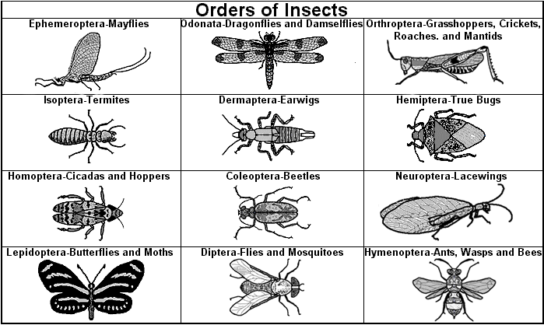
Hymenoptera
ants, wasps, bees

 | 22 |  |  | 6 |  |  | 1 |  |  | 1
 | 12 | 2 | 2 | 3 | 7 | 1 | 2 | N/A | 5 | 2 | N/A | 7
Coleoptera
Beetles- hard wings

 | 65 |  |  | 8 |  |  | 6 |  |  | 4
 | 30 | 0 | 7 | 5 | 5 | 0 | 4 | N/A | 5 | 7 | N/A | 3
Heteropera
Stink bugs

 | 5 |  |  |  |  |  | 1
 | 1 | 0 | 0 |  | 0 | 0 |  | N/A | 0 |  | N/A | 0
Homoptera
Aphids, cicadas

 | 10
 | 6 | 0 | 9 | 1 | 9 | 0 | 1 | N/A | 1 | 3 | N/A | 0
Orthoptera
Grasshoppers, crickets, weta

 |  | 0 | 1 |  | 1 | 0 |  | N/A | 2 |  | N/A | 0
Neuroptera
Lacewings

 |  |  | 0 |  |  | 6 |  | N/A | 6 |  | N/A | 5
Odonata
Dragonflies
 |  | 1 | 1 |  | 0 | 0 |  | N/A | 0 |  | N/A | 0
Lepidoptera
Butterflies& moths

 | 51 |  |  | 3 |  |  | 5 |  |  | 8
 | 46 | 9 | 0 | 3 | 20 | 0 | 5 | N/A | 6 | 3 | N/A | 23
Class Arachnida – Spiders
Though not in the survey, spiders were caught in the traps.

 | N/A | 3 | 4 | N/A | 15 | 4 | N/A |  | 1 | N/A |  | 0

