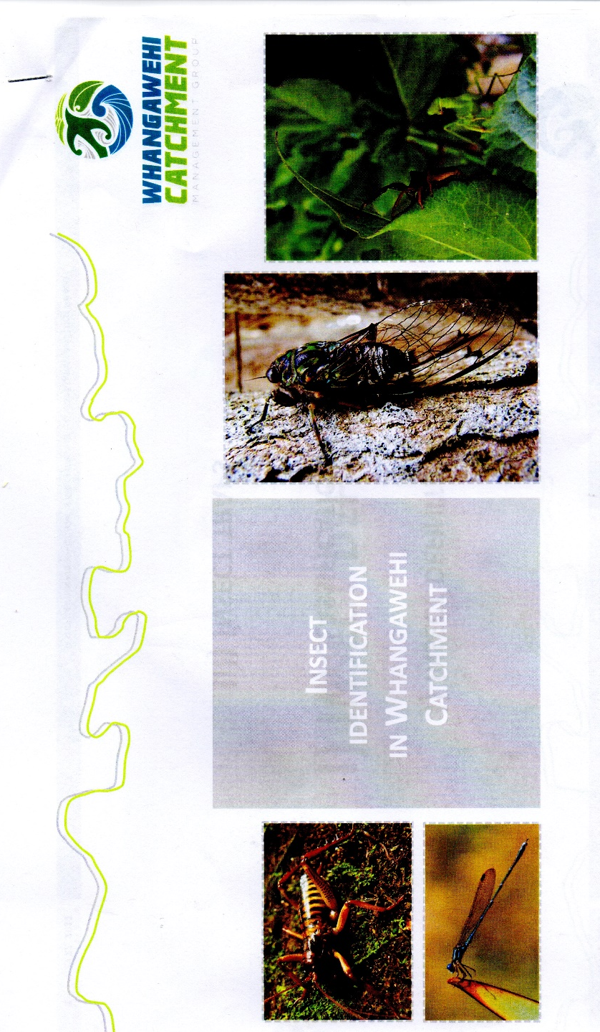

Insect survey 2017 - Janice Edwards
The survey was conducted almost one year since the initial survey had been done.
The weather was good, often overcast and quite cool in the evenings.
Both traps set were down near the Whangawehi near the same places that had been used in the previous year.
Trap site 1 - near the old Titoki trees
Trap site 2 – near where the track leaves the pine forest
Traps were in place for 13 days.
When collected at site 1, one section of the 2 mesh trap had become disconnected from the jar and would had affected the insect numbers collected.
Both sites were in knee to thigh height grass.
I decided, given the extensive spraying of the wetlands that little would be gained by a trap being set around the wetlands. Once vegetation has re-established, it would be a fair comparison of collected data next year.
My thanks to Graeme and Pat in giving me transport and help in this project.
Thanks also to Lucy and Louise for providing the training and preparatory work.
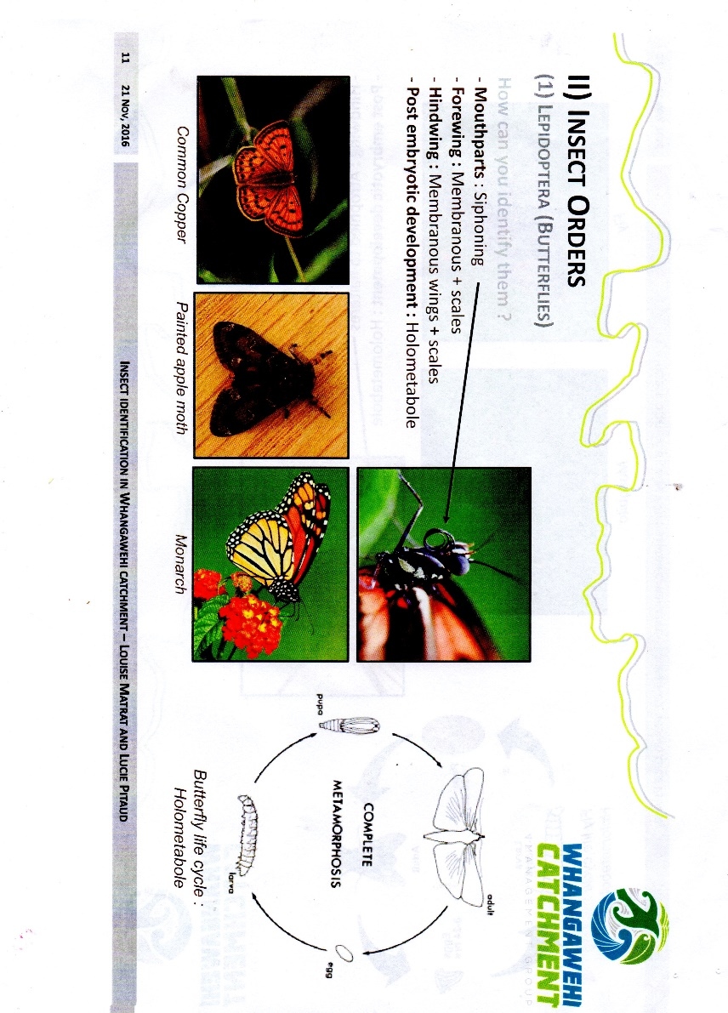
Trap 1 Trap 2

1 Common Copper
Small moths &
butterflies

20

_____________________________________
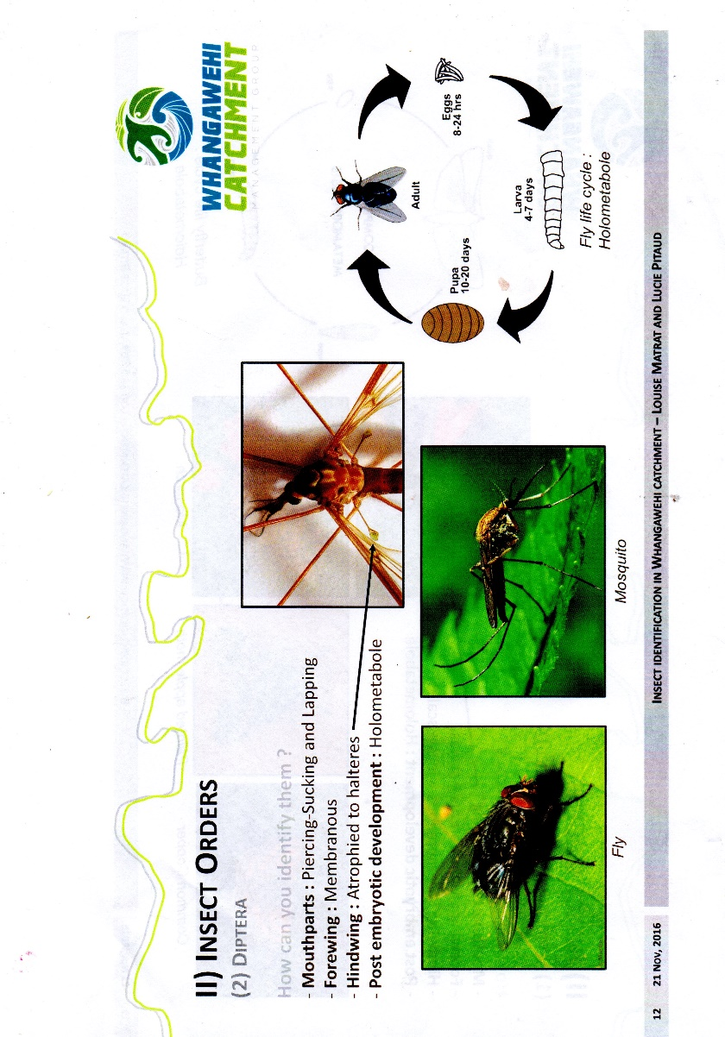
28+ mosquitoes 248+ mosquitoes
1 fly 8 flies
Other insects were Other insects were
very small very small

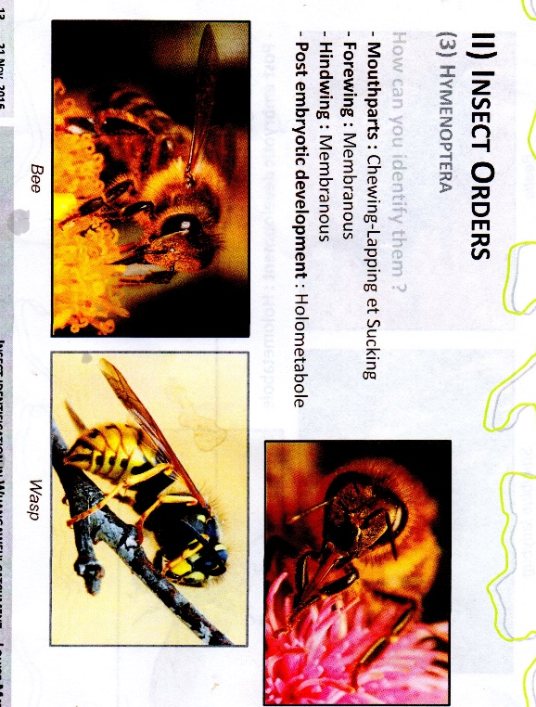
245 1497
_____________________________________

Bumble bee Wasps
Honey bee

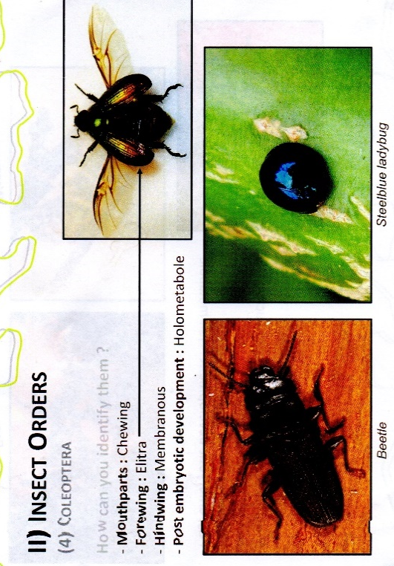
2 7

3 weevils

0 5

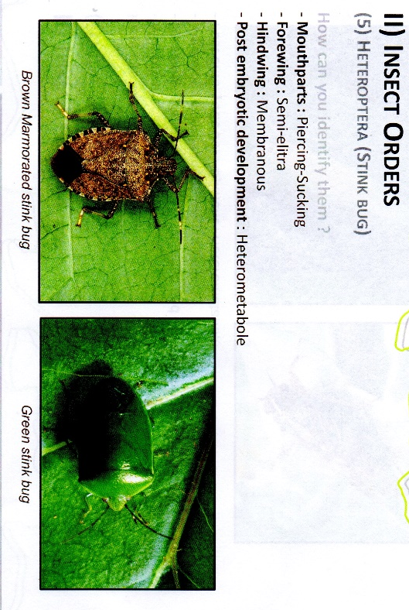

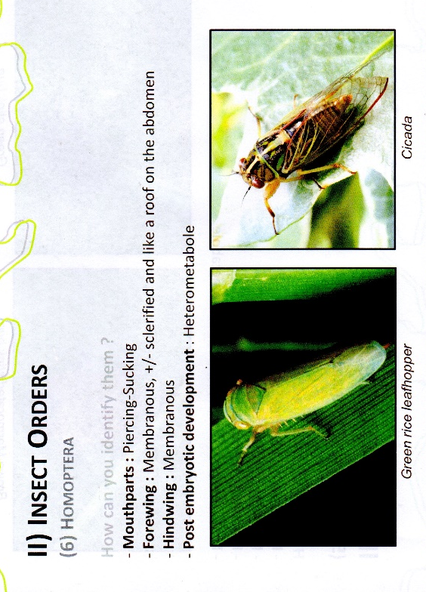
0 0

____________________________________

Small insects

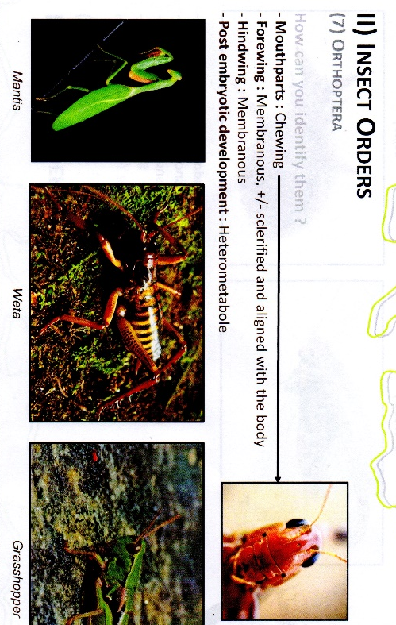
0 9
____________________________________

1 very tiny
preying mantis

0 1

Nothing was found in the insect orders of Neuroptera or Thysanoptera
INSECT ORDER
(10) Anisoptera

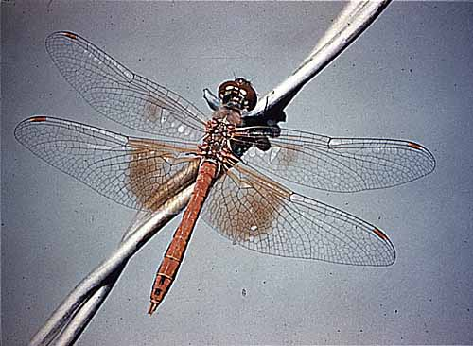
small dragonfly

0 1
_____________________________________
Class Arachnida – Spiders
Though not in the survey, spiders were caught in the traps 3 15

